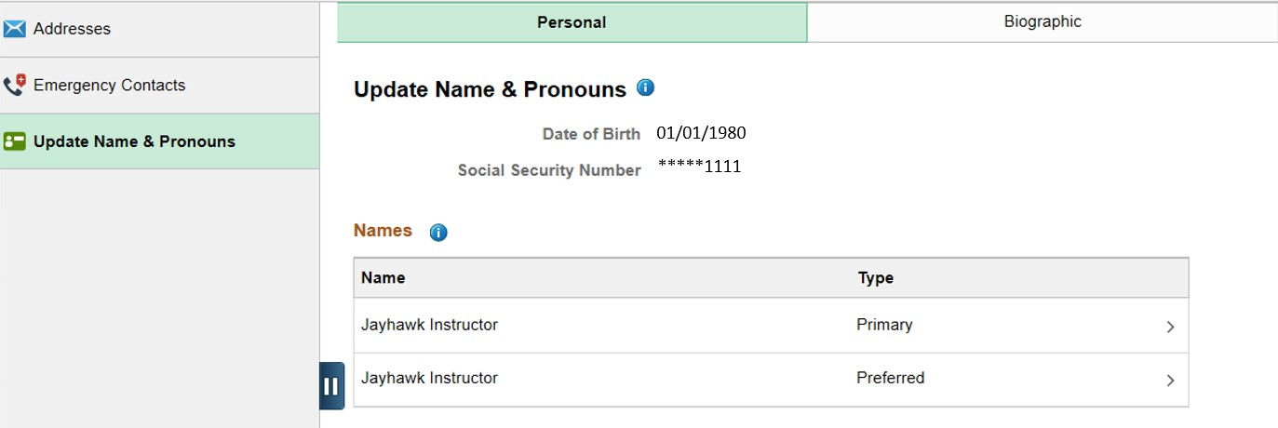
Updating Your Preferred Name

Students and faculty have the option to use a name other than their legal (primary) name to identify themselves. The University of Kansas will use that preferred name wherever possible unless the usage of the legal name is mandated. The preferred name will be sent to Blackboard and will be listed on class and grade rosters, among other processes.

First, log onto Enroll & Pay and click on the Campus Personal Information tile under Enroll & Pay.

Depending on your access, you will have the option to update various pieces of information under Personal Details. To update your Preferred Name, click on Update Name & Pronouns and then on the Preferred name type.

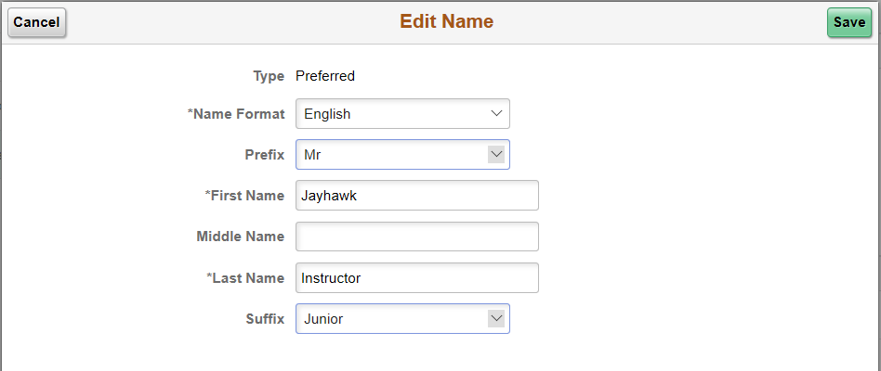
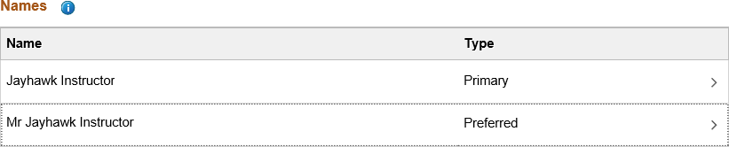
Faculty and students can make adjustments to their preferred name here. Click Save when complete.

The preferred name will now appear on the KU Personal Details/Update Name & Pronouns page.

To change your Legal/Primary Name, please refer to this website for more information: https://registrar.ku.edu/update-or-correct-your-information

